Xiaosheng Zhang, *Student Member, IEEE*, Tao Ding, *Senior Member, IEEE*,Chenggang Mu*, Student Member, IEEE,* Biyuan Zhang*, Student Member, IEEE,* Yuankang He, Mohammad Shahidehpour, *Fellow*, *IEEE*

Data and Parameters

The simplified topology of a regional power grid in China is shown in Fig. 1. This system is a high-penetrated renewable power system. The capacity of conventional thermal plants, hydro plants, and RES plants is shown in Table I. The scenario tree is constructed by using the Latin Hypercube Sampling method. Fig. 2 plots the forecasted RES output and gross load profiles of the regional power grid. The maximum and minimum load demands are 95,000 MW and 83,500 MW.

The parameters of the adding VESs are listed in Table II.



Fig. 1 Simplified topology of a regional power grid in China.

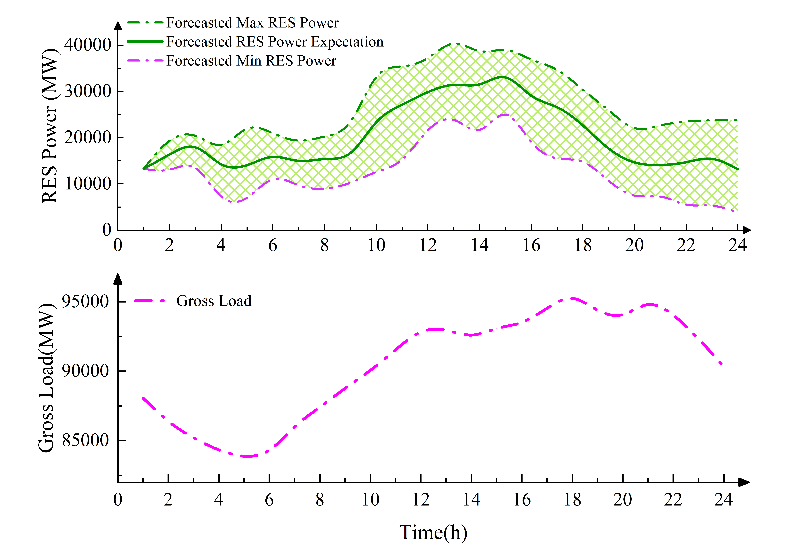

Fig. 2 (a) The forecasted RES output and (b) Gross load of the regional power grid

Table I. Capacity of Different Types of Units (MW)

|  |  |  |  |  |
| --- | --- | --- | --- | --- |
| Units | Thermal | Hydro | RES | Total |
| Capacity(MW) | 102643 | 31323 | 60738 | 194704 |

Table II Parameters of the VES

|  |  |  |  |
| --- | --- | --- | --- |
| *g* | Bus | PG j,max/PG j,min (MW) | up *j*/down *j* |
| 1 | 5 | 1200/600 | 300 |
| 2 | 16 | 2400/1200 | 600 |
| 3 | 24 | 2400/1200 | 600 |
| 4 | 39 | 1200/600 | 300 |
| 5 | 48 | 1920/960 | 480 |
| 6 | 140 | 2400/1200 | 600 |
| 7 | 168 | 900/450 | 225 |
| 8 | 169 | 2400/1200 | 600 |